Wickers, Jason (DI SW GS&CS GS&S LCS)

jason.wickers@siemens.com



**Install Guide**

Teamcenter Requirements Integration for MATLAB/SIMULINK

Abstract

This document will provide a brief introduction to what the Teamcenter Requirements integration is and how to install it.

**Disclaimer**

This document is intended to provide Teamcenter deployment information, and related observiations and recommendations. Siemens Korea Digital Industries is providing this information as is, without warranty of any kind. **Siemens Korea Digital Industries hereby disclaims and assumes no responsibility or liability for any results that occur due to the use of the information contained in this document.**

All product designations may be trademarks or other rights of Siemens AG, its affiliated companies or other companies whose use by third parties for their own purposes could violate the rights of the respective owner.

**Document History**

|  |  |  |  |
| --- | --- | --- | --- |
| **Version** | **Date** | **Author** | **Description** |
| .1 | 2022-05-11 | Wickers, Jason | Documentation for Beta Release |
| .1.1 | 2022-05-19 | Wickers, Jason | Added icon location and logging configuration section |
| .1.2 | 2022-05-27 | Wickers, Jason | Updated SSL setup guidance and added MATLAB python compatibility detail |
| .1.4 | 2022-09-19 | Wickers, Jason | Removed logging as it was causing library usage issues in MATLAB |

Table of Contents

Introduction 3

Scope (what it is): 3

Out-of-Scope (what it *is not*): 3

Key Components/Feature 3

Installation 3

Pre-Requisites 3

Install C-Python 3.8+ for 64bit: 4

MATLAB Pre-requisites: 4

Download and Install Python 4

Upgrade PIP 4

Install PIP Packages 5

Install Siemens Package for Python 5

Set Path in MATLAB 5

Register Teamcenter Integration 5

Add Favorites Command to MATLAB 5

Configuration 6

Credentials 7

Secure Sockets Layer (SSL) 7

Uninstall 11

Known Issues / Workarounds 12

# Introduction

The main objective of this integration is to have a consistent requirements integration with MATLAB/Simulink regardless of source. The reasons for this are:

1. Allow requirements to work as designed by MATHWORKS in the MATLAB eco-system, reducing integration support costs
2. Expand Teamcenter Requirements capability offering to MATLAB/SIMULINK customers

## Scope (what it is):

* Multiple requirement specification import and update from Teamcenter into SIMULINK Requirements
* Implementation traceability of Teamcenter Requirements with MATLAB/SIMULINK model data
* Bi-directional traceability between Teamcenter Requirements and MATLAB/SIMULINK

## Out-of-Scope (what it *is not*):

* Model version management
* System Architecture integration

# Key Components/Feature

* Teamcenter/Active Workspace
  + Teamcenter Author
  + Teamcenter Requirements
* MATHWORKS
  + MATLAB / Simulink
  + Simulink Requirements
* Python and Pip Packages – www.python.org
  + Python
  + PIP Package - Inflection (inflection) - https://github.com/jpvanhal/inflection
  + PIP Package - BeautifulSoup (bs4) - https://www.crummy.com/software/BeautifulSoup/
  + PIP Package - Requests (requests) - https://docs.python-requests.org/en/master/
  + PIP Package - Certifi (certifi) - <https://certifiio.readthedocs.io/en/latest/>

# Installation

## Pre-Requisites

* MATLAB/SIMULINK already installed and includes:
  + MATLAB / Simulink
  + Simulink Requirements
* Teamcenter/Active Workspace environment established for integrating and includes:
  + Teamcenter Requirements

## Install C-Python 3.8+ for 64bit:

### MATLAB Pre-requisites:

MATLAB only supports specific versions of Python. Please download and use the appropriate Python version for your MATLAB version, you may reference:

* <https://www.mathworks.com/content/dam/mathworks/mathworks-dot-com/support/sysreq/files/python-compatibility.pdf>

### Download and Install Python

Python – <https://www.python.org> – python is an intuitive scripting/programing language that lets you work quickly and integrate systems more effectively.

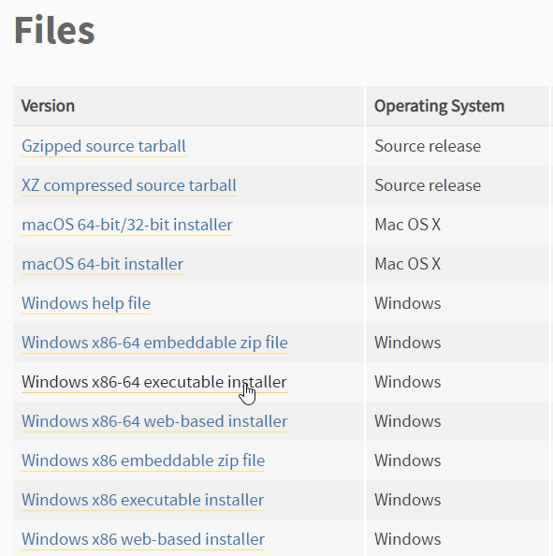

### Upgrade PIP

Pip - <https://pypi.org/project/pip/> - pip is the package installer for Python. You can use pip to install packages from the Python Package Index and other indexes.

Run the following from the command prompt:

|  |
| --- |
| python -m pip install --upgrade pip |

### Install PIP Packages

In this section you will install packages from Python’s standard package manager. The packages being installed are required dependencies of the integration.

Run the following from the command prompt:

|  |
| --- |
| pip install certifi  pip install requests  pip install inflection  pip install bs4  pip install cryptography |

## Install Siemens Package for Python

In this section you will install the python integration for Teamcenter.

Double-click on : 

Follow the Wizard, clicking Next and finally click Finish when done.

## Set Path in MATLAB

In this section you will set the search path of MATLAB so that it can find the Teamcenter integration code.

1. In Home Tab, click on 
2. Choose 
3. Navigate to: <YOUR_PYTHON_INSTALL_PATH> \Lib\site-packages\teamcenter\matlab
4. Click Save
5. Click Close

## Register Teamcenter Integration

In the MATLAB window type:

Teamcenter_Integration;

## Add Favorites Command to MATLAB

In this section you’ll create a Favorite command to support initial import of Teamcenter Requirement Specifications.

1. In Home Tab, click on 
2. Choose 
3. Fill-in as below:

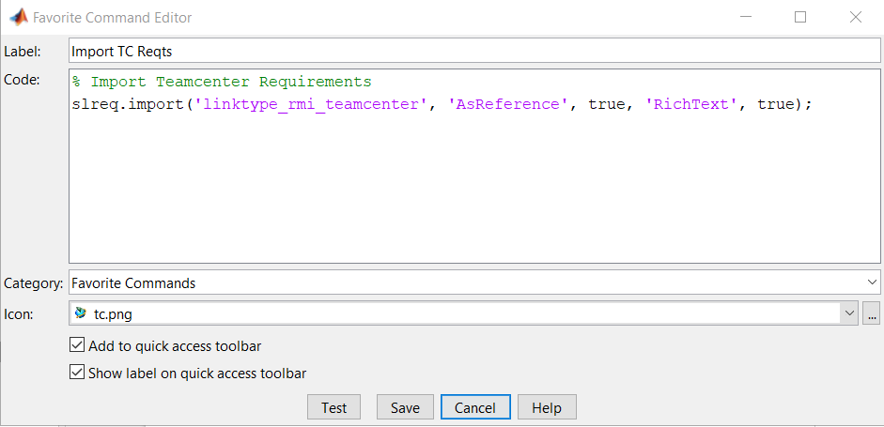

* 1. Note that the tc.png icon file can be found at: <YOUR_PYTHON_INSTALL_PATH> \Lib\site-packages\teamcenter\icons\tc.png

1. Click Save.
2. You will see the Favorite Command in MATLAB:



# Configuration

In this section you will configure the DEFAULT alias for connecting to Teamcenter.

To configure the environment you wish to connect to, modify the alias file at the below: <YOUR_PYTHON_INSTALL_PATH>\teamcenter\tcaliases.ini

|  |
| --- |
| [DEFAULT]  #either http or https  scheme = http  #hostname or ip of active workspace gateway server  host = siemensdc  #activeworkspace port  port = 3000  #fms port to connect to  fmsport = 4544  #awpath for active workspace  awpath=/62/wd142/aw/  #basepath for JsonRestServices  basepath = /tc/JsonRestServices/ |

# Credentials

The integration requires credentials to be pre-defined for each alias currently. To do this, a credentials script exists. You may think of this like creating a password file for Teamcenter.

Credential files are stored in: <YOUR_PYTHON_INSTALL_PATH>\teamcenter

Usage: tc_credential.py [options]

|  |
| --- |
| Options:  -h, --help show this help message and exit  -a ALIAS, --alias=ALIAS  alias credential is for |

Example 1:

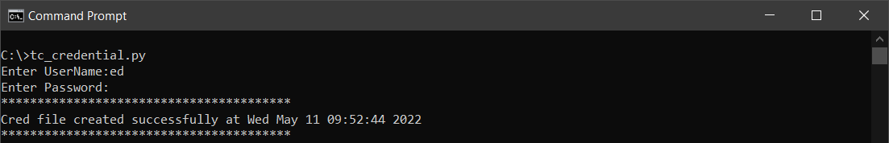

Example 2:

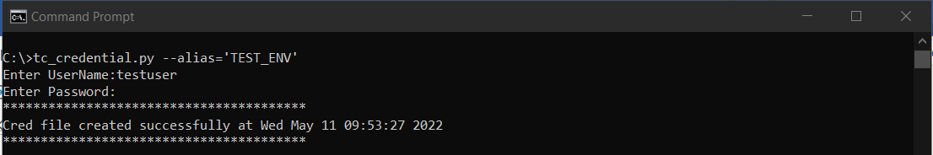

# Secure Sockets Layer (SSL)

The integration has SSL Verification enabled. Therefore communication via HTTPS requires the chain of ssl certificates for your active workspace url and added to cacert.pem.

To find the location of cacert.pem, you can do the following:

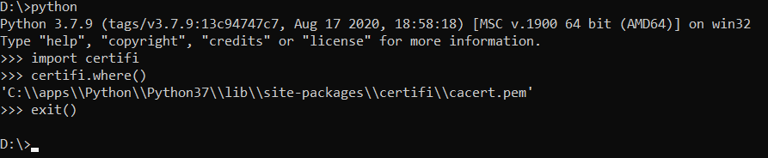

Next:

1. Using your web browser (Edge Chromium, Chrome, etc.), download the chain of certificates used in your Teamcenter installation and specified in your aliases.ini (see HOST) and save as Base64 encoded .cer files.

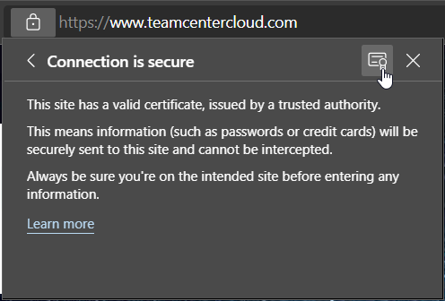

Figure 1 Edge Chromium start save of certificate

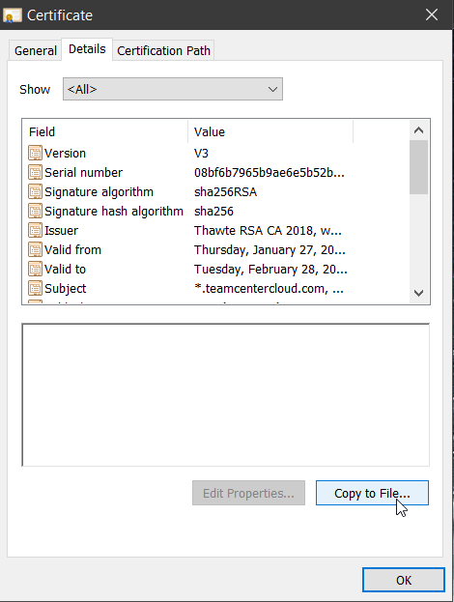

Figure 2 Where to go to save the certificate to file

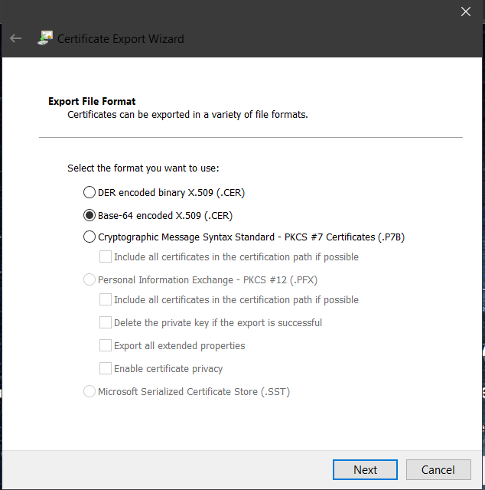

Figure 3 Export file format should be Base-64

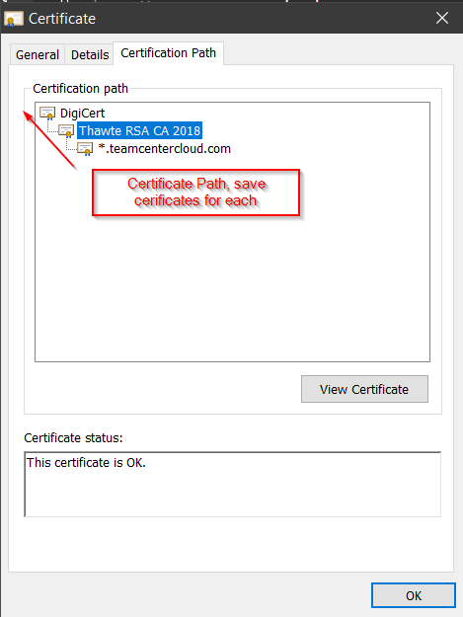

Figure 4 Click on each certificate path level and "view certificate" to save each certificate as file

1. Open the cacert.pem in a notepad and add every downloaded certificate contents (---Begin Certificate--- *** ---End Certificate---) at the end. Do not remove the ---Begin Certificate--- header or ---End Certificate--- footer, it must be included.

# Uninstall

The python based Teamcenter integration can be uninstalled from within Apps & features in Windows.

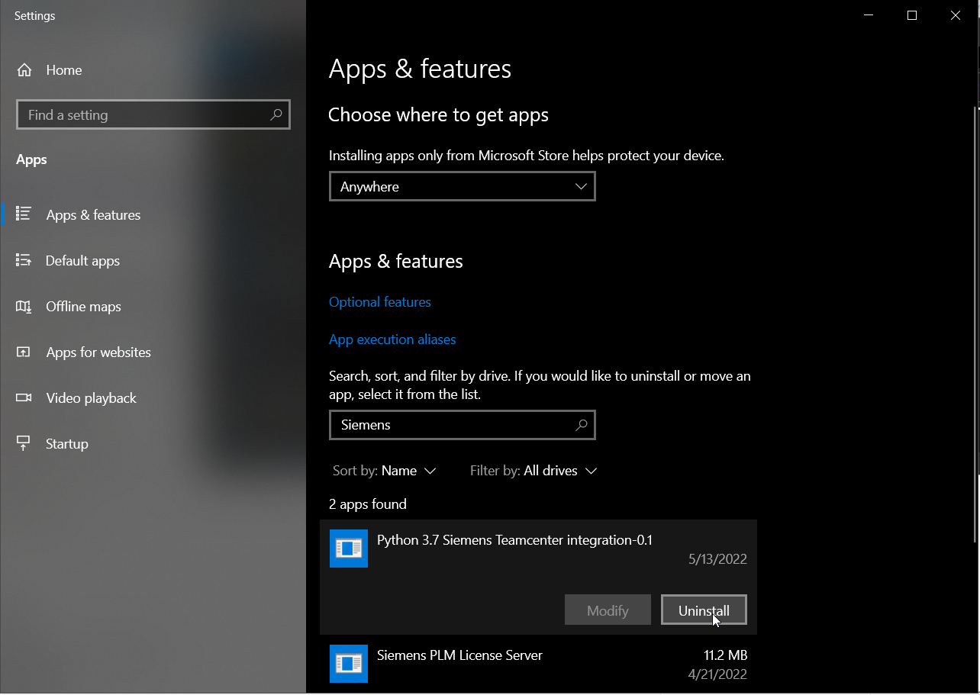

# Known Issues / Workarounds

1. **Re-installing the python integration overwrites tcaliases.ini**
   * *Description:* During installation the tcaliases.ini is overwritten with the default file provided by the installer.
   * *Workaround:* Backup tcaliases.ini before installing updates to or reinstalling the integration
2. **Un-installing the python integration removes modified tcaliases.ini**
   * *Description:* During uninstall the tcaliases.ini containing environment specific modifications is removed by the uninstaller while the alias credentials remain.
   * *Workaround:* Backup tcaliases.ini before uninstalling the integration